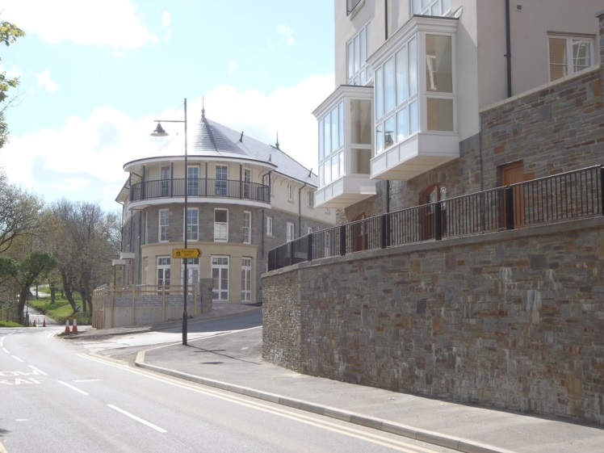

**Coed Darcy Residential Development – 56 Units**

**Design, manufacture and erection of the 56 dwellings in the , consisting of 2 & 3 storeys apartments and houses ranging from two to four bedrooms. Constructed in 2008, Seven Oaks provided the timber frame superstructures, steel frames and roof structures for all 56 dwellings on this project. All dwellings were delivered to Secured by Design and BREEAM Eco homes Excellent standards.**

**Type of Project - Residential**

**Client – Dawnus Construction Ltd**